Manjushri Kadampa Meditation Centre

Conishead Priory, A5087 Coast Road, Ulverston, Cumbria, LA12 9QQ

Tel: 01229 584029 (Ext 234), Email: visits@manjushri.org, www.manjushri.org

Dear Teacher,

Visiting the Kadampa Buddhist Temple in Ulverston, Cumbria in 2015

Many Teachers are bringing their students to the modern Kadampa Buddhist Temple which is an amazing place that is peaceful and inspiring. They meet a Buddhist teacher who shares their experience of living a modern Buddhist way of life and so brings alive what the students are learning at school or college.

You can make it a complete day out - in addition to the spiritual aspect you could include your own history, environmental and art studies around the historic house, gardens, woodland and beach. Or combine the trip with a visit to another spiritual place or educational attraction nearby - we can make suggestions if you like.

Please note we only have visits from Monday to Thursday. When you have some preferred dates please email visits@manjushri.org and check if they are free. We are finding emails quicker and more efficient than phone calls. Please note we are closed during our International Buddhist Festivals so check the dates in the ‘How to Book in 2015’ section.

Sometimes we get requests for a Buddhist teacher to visit a school or college. However students can get a greater understanding of the daily life of modern Buddhists from an educational visit to the Temple then we can explain in a visit to you. Also we don’t have enough staff to undertake a visit to you as we are concentrating our efforts on fulfilling the demand for Temple visits. However if you can’t visit us we will consider a special request, or you can contact our nearby sister Centres:-
Blackpool E: mail@meditationinblackpool.org.uk, www.meditationinblackpool.org.uk, Tel: 01253 352 721
Carlisle E: info@uma.org.uk, www. www.meditateincarlisle.org.uk, Tel: 01228 319344
Lancaster E: info@meditationinlancaster.org, www.meditationinlancaster.org, Tel: 01524 596 108
Liverpool E: info@meditationinliverpool.org.uk, www.meditationinliverpool.org.uk, Tel: 0151 726 8900
Manchester E: info@meditateinmanchester.org, www.meditateinmanchester.org, Tel: 01618 617 012
Preston E: mail@meditateinlancs.org.uk, www.meditateinlancs.org.uk, Tel: 01772 884 919
Or visit www.kadampa.org to find a Centre near you (box at top right of homepage).

We hope you will be able to visit us. Please email me if you would like more information or want to come for a preliminary research visit.

Yours sincerely,

Geoff Roe

Geoffrey Roe, Visits Manager

Email visits@manjushri.org, Tel 01229 584029 Ext 234



Registered Charity No. 1015054, Company Limited by Guarantee No. 2758093 (England)

A part of the New Kadampa Tradition - International Kadampa Buddhist Union

RISK ASSESSMENT FOR EDUCATION VISITS AT MANJUSHRI KMC

CONISHEAD PRIORY, ULVERSTON, CUMBRIA, LA12 9QQ

Activity | Hazard | Level of risk | Action by visiting staff
Arriving on foot | It is dangerous for pedestrians to cross the A5087 Coast Road to enter the main entrance to Conishead Priory by the tourist sign. Vehicles travel fast around the bend from Bardsea and a fatal accident has occurred. | High | If you are being dropped off by public bus at the main entrance on Coast Road please take great care crossing the road. If you are walking from Ulverston please take the first entrance road on the left by North Lodge house and come along the estate road through the woods.
Walking on entrance roads, in car parks and around College gardens. | Vehicular traffic on estate roads and in car park. Traffic calming bumps have been installed on the main drive. | Medium | Warn students about traffic before getting off transport, and to be careful in car park. Increased staff awareness and supervision.
 | Building Work including access towers, scaffolding, vehicles and machinery. | Medium | Should be barriers and warning notices around potential hazards. School staff informed of any special hazards by Visit Leader at beginning of visit and risk personally assessed by school. Choose alternative route, keep clear of hazard.
Walking inside College and Temple | Slippery floors after cleaning | Low | Warn students not to run.
Walking inside College and Temple | Two or three steps at entrances and in hallway. Ramps for wheelchairs. | Low | Warn students to watch where they are walking.
Walking inside College and Temple | Doors with automatic closers (fire doors) | Low | Warn students to be careful going through large and heavy doors.
Walking in Woods | One steep incline path into to woods by Reception entrance of main building, otherwise level paths. | Low | Warn students of steep incline and ask them to keep to main paths. Don’t use steep white stone steps. Don’t swing on branches of trees.
Walking in Woods | Fallen trees and branches will be cordoned off with red and white warning tape. | Medium | Warn students to take care when diverting off path to go round fallen tree or branch.
Walking in Woods | Lake and streams | Medium | Warn students to keep to path and away from water. Visit can avoid this area if necessary.
Walking in Woods | Farm animals in adjacent fields - mainly sheep, cows and horses. Domestic dogs on lead or off lead. | Low | Warn students not to approach animals and keep back from fences.
Walking in Woods | Tunnel under concrete estate road between Art Studio and lake. | High | Do not enter tunnel from either entrance. Tunnel may collapse due to heavy vehicle on concrete estate road.
Walking on Beach | If you walk through our woods to Morecambe Bay Tidal Estuary it should be safe if you stay on the pebble beach. Do not walk out onto the sands / mudflats. Due to fast incoming tides, deep channels and quicksand lives have been lost. | Medium | Stay on pebble beach. Warn students not to go near water or sands / mudflats, to stay within sight. Ensure close supervision. You may see people walking on the sands further along the coast at Bardsea and think that it is safe, but they are taking a big risk - it is dangerous.
Food | Allergies. Sweets, drinks and crisps etc. available in College shop. | Low | Remind students about food allergies. Supervise shop access.

Wheelchair access. There are ramps to the Temple and main historic building.
In the event of minor accident or injury First Aid Kits located in Reception and the Temple. A 999 call gets a 10 minute response from the Ambulance station 1½ miles away in Ulverston. The Accident and Emergency Department at Furness General Hospital in Barrow is 10 miles / 20 minutes away via the fast A590 trunk road.
Risk Assessment prepared by Geoffrey Roe, Visits Manager, Manjushri KMC. 23 March 2015

Education visits to the Buddhist Temple in Ulverston, Cumbria
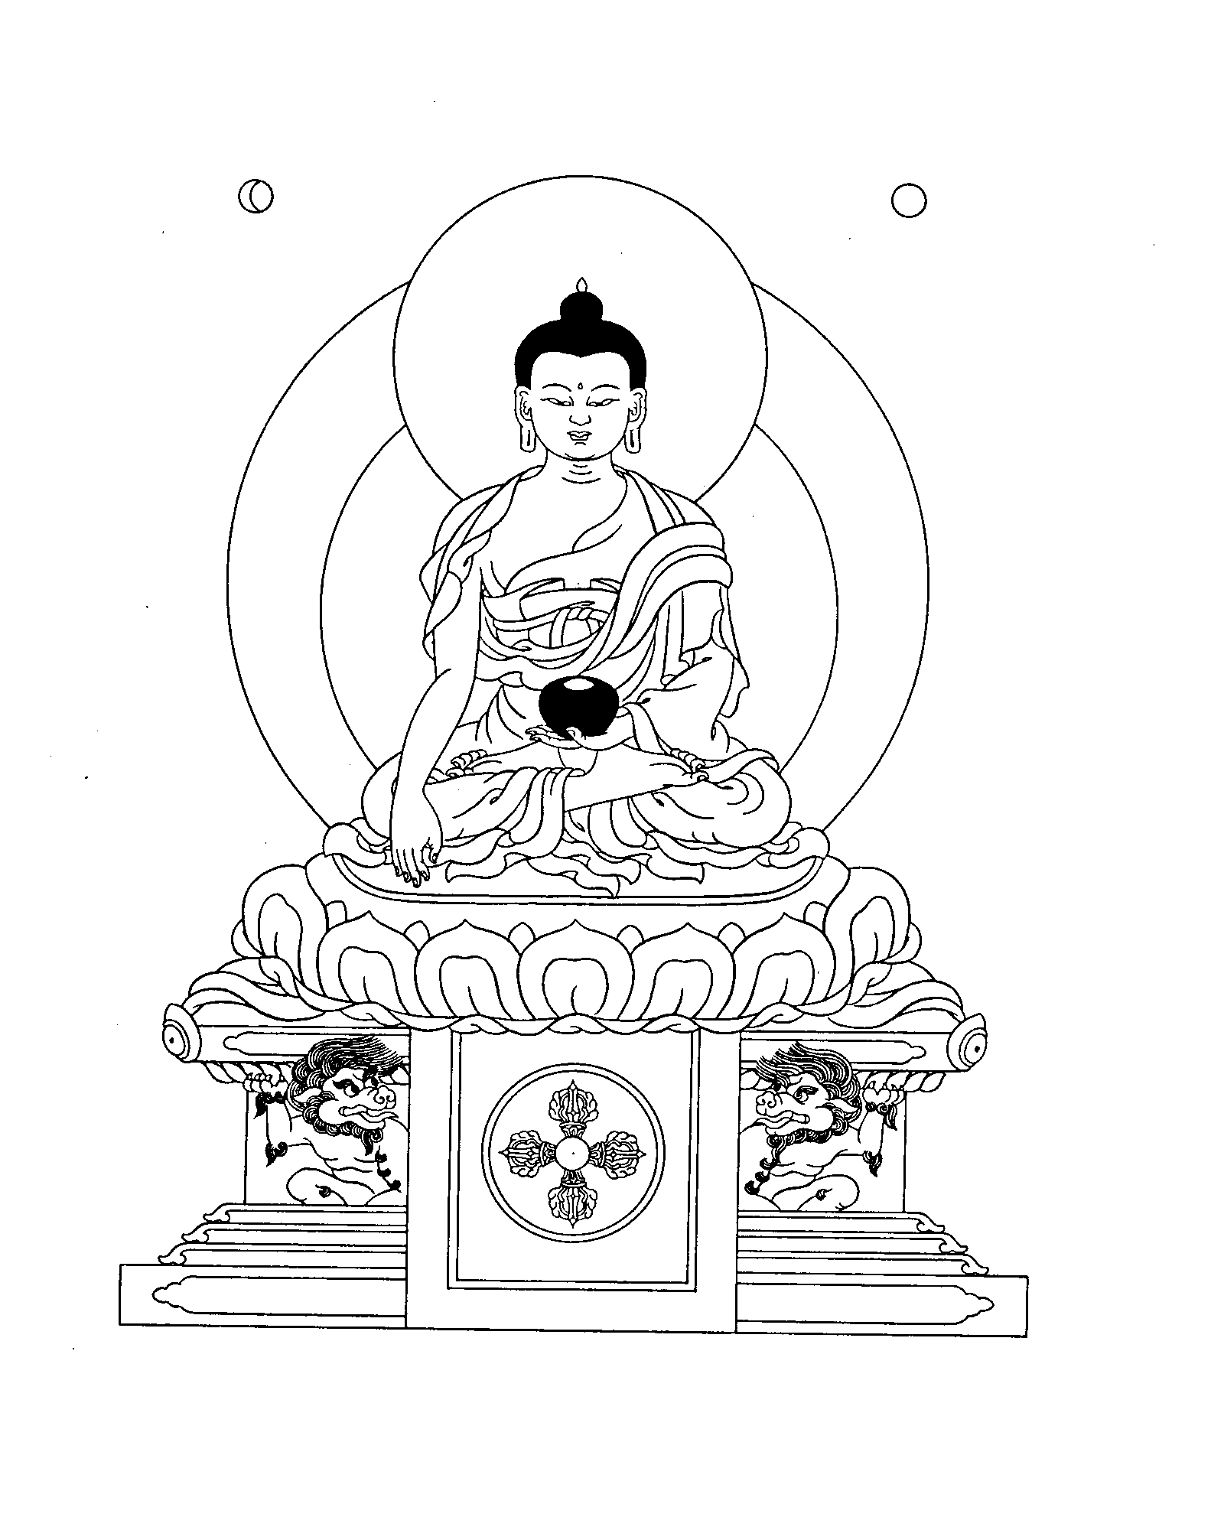
Buddha Shakyamuni

Who are we?

We are a Kadampa Buddhist College, founded in 1977, whose main function is to train lay and ordained people to become Buddhist teachers. This is the original Centre from which many Kadampa Centres have been established around the world. We have been hosting education visits for many years.

The Temple is a special place. As you can see at www.manjushri.org the Temple is a beautiful and peaceful holy place that contains statues and paintings of Buddhas, Buddha’s scriptures, shrines with offerings, and many Buddhist symbols. Teachers are often surprised at how responsive their students are when they are in the Temple.

‘Just looking at the Temple with a happy mind brings inner peace’.
Venerable Geshe Kelsang Gyatso

What happens during your visit?

1½ hours is spent with a Buddhist teacher. Visits can start from 9.30am and begin in the historic house where we meet Buddha Maitreya. Then we walk through the gardens to the Temple, the centrepiece of which is a large statue of Buddha Shakyamuni. It is a calming and inspiring environment. We can explain Buddha’s life story and the main Buddhist beliefs. We can include a simple relaxing meditation, or more structured meditation to develop a positive mind like love.

Our teachers are familiar with the Key Stages of the Religious Education ‘Agreed Syllabus’ for nearby Education Authorities. Please specify on the booking form what you would like our teacher to include so it ties in with your students classroom studies.

After your 1½ hour session with our teacher you could draw Buddhas in the historic house, fill out worksheets you have prepared, relax in the gardens or walk to the beach.

If you have extra time you could include your own history, environmental and art studies around the historic building, in the woods and on the estuary shoreline of Morecambe Bay. The historic family mansion is an imposing example of 19th century Gothic architecture and on the site of the 12th century Augustinian Priory (now demolished).

Who are the Kadampas?
Kadampa Buddhism is a Mahayana Buddhist school founded by the great Indian Buddhist Master Atisha. His followers are known as ‘Kadampas’. ‘Ka’ means ‘word’ and refers to Buddha’s teachings, and ‘dam’ refers to Atisha’s special Lamrim instructions known as ‘the stages of the path to enlightenment’. Kadampa Buddhists are encouraged to use all of Buddha’s teachings as practical methods for transforming all their daily activities into the path to enlightenment. Kadampas are modern Buddhists who take Buddha’s teachings as personal advice and put them into practice every day to solve their own problems and help others find peace and happiness.

You can sit in the gardens to enjoy your packed lunch or use our Dining Room (holds 90 people) up to 1pm if it is cold or raining. The shop is open from 11am to 5pm. Sorry but the Café is not available for education visits.

How to book in 2015

Please note we only have visits from Monday to Thursday. School visits start on Mon 9 Feb. We are finding emails quicker and more efficient than phone calls. Please email your preferred dates to visits@manjushri.org. We will reply by email to say if the dates are available and suggest alternatives if they are booked.

Please note we are closed for Education Visits during our Buddhist Festivals and College summer holiday in 2015:-
Mon 11 May and restart on Tue 9 June
Mon 13 July and restart on Tue 1 Sept
Wed 30 Sept and restart Mon 12 Oct

When we have agreed a provisional date please email, fax (01229 580080) or post the booking form. We will email a confirmation letter.

The Visits Manager is often out of the office so if want to discuss the visit please email your phone number, OR leave a message with Reception (01229 584029), and Geoff will phone you back.

Our 2015 charges are:-
- Pre-school, Primary - £2.50 each
- Secondary, Sixth Form - £3 each
- Further Education - £4 each
- There is no charge for teachers or parents.
Please arrange payment with the Visits Manager during your visit. You can pay by cheque (made payable to ‘Manjushri KMC’) or ask for an Invoice so a cheque can be sent later.
Getting here - Sat Nav LA12 9QQ.
We are 30 minutes / 26 miles from Junction 36 on the M6. Follow signs for Barrow. After 3½ miles from motorway take exit onto the A590 for Barrow. In Ulverston take second exit at roundabout by Booths Supermarket and pass Shell garage. Take second left onto the A5087 Coast Road signposted Bardsea / Croftlands and ‘Coastal route to Barrow’. We are two miles along on the left hand side - look for tourist sign. Coach parking is in front of the historic mansion.

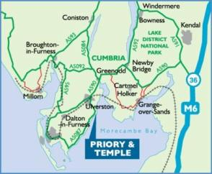

Websites
www.buddhistbooksforchildren.com - Four new books on Buddhism for Children.
www.emodernbuddhism.com - Download a free copy of 'Modern Buddhism'.
www.manjushri.org - Everything about events at Manjushri Kadampa Meditation Centre.
www.kadampa.org - Kadampa Buddhism worldwide. Find a Centre near you.
www.tharpa.com - Online shop for Buddhist books, posters, postcards, statues and more.
www.kadampafestivals.org - NKT International Festivals and Celebrations.
www.kadampatemples.org - Be inspired to help build Temples for World Peace around the globe.

